Binding items (issues) into a new separate issue and then viewing the withdrawn (deleted) items | 

Yoel Kortick
Senior Librarian

In this document we will show it is possible to view items which get withdrawn (deleted) during the binding process.

ONE
The journal “Journal of neuroendocrinology” (MMSID 991233030000121) has 5 items.
Four of the items are issues from 2022.
The first issue of 2023 has also arrived

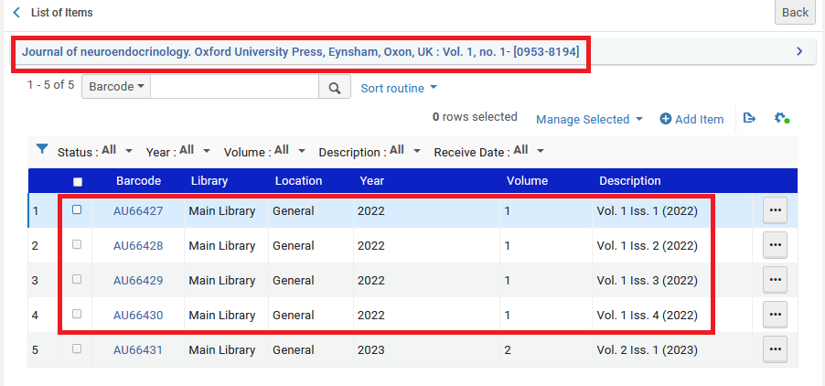
TWO
We will bind the four issues of 2022 into one volume and call it “Vol. 1 Iss. 1-4 (2022)”
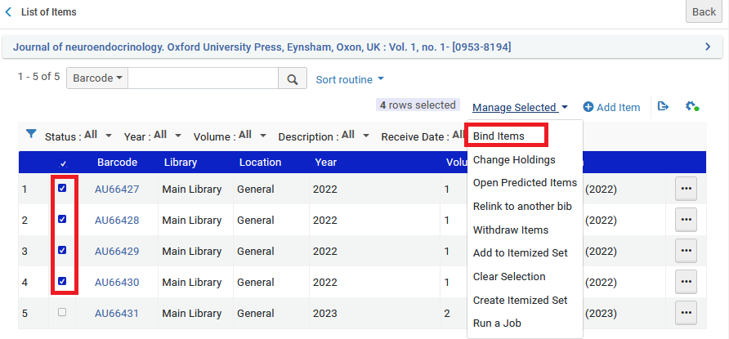
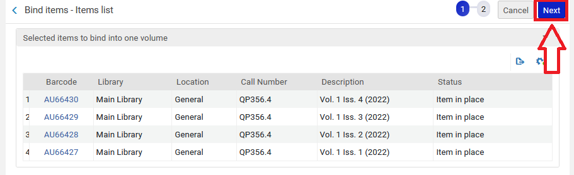
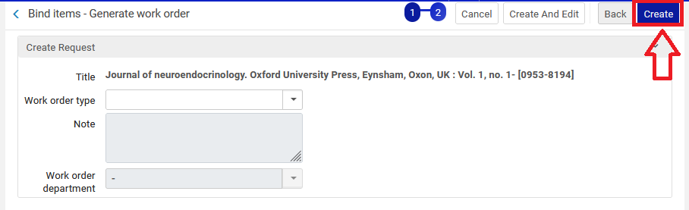
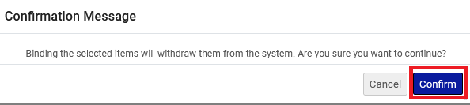
THREE
Now we have the bound issue and the one issue from 2023. The four issues from 2022 have been deleted (withdrawn).

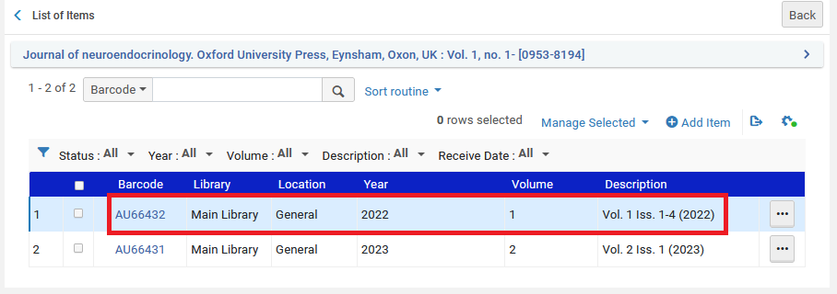
FOUR
Now we will look at all the items in Alma Analytics. We see (in red square below) the deleted ones. Not in the red square we see the active ones. We could of course add many more fields to this report.
